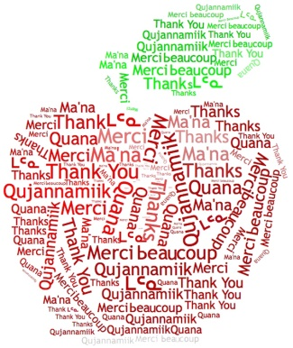

Thank You for Making a Difference!
Official Entry Form
Email eryan@ntanu.ca & pmacneil@ntanu.ca

Students can celebrate teachers by nominating them and describing how these teachers have made a positive difference in their life! Students can enter as often as they want and nominate as many teachers as they like! (Complete an entry form for each teacher nominated). The entry form can be completed in your language of choice. DEADLINE for submissions is MARCH 18th, 2026.

Teacher Name: ____________________________________ Student Name: _________________________
Region: __________________________________________ Student School: ________________________
Teacher School: ____________________________________ Student Age: _________
School Address: ________________________________________________________________
Students can write a poem, create a visual, and/or write a short paragraph about the teacher they are nominating.


Draw to take place on March 28, 2026.
Winning Students and Teachers will receive an iPad!
One draw per region (Qikiqtani, Kivalliq, and Kitikmeot)
An additional Territorial draw: Winning student will receive a computer
and a roundtrip flight for the teacher! (From their community to/from Southern hub)

